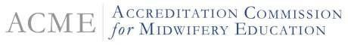
2000 Duke Street, Suite 300 ‧ Alexandria, Virginia 22314 ‧ (703) 835-4565 ‧ www.theacme.org

Action Notice
February 2, 2024
Please be advised that the Board of Review for the Accreditation Commission for Midwifery Education (ACME), the recognized accrediting agency for midwifery and nurse-midwifery education programs, held an off-cycle review meeting January 16, 2024 and administered the following actions:

Substantive Changes
Approved a substantive change for Rutgers, The State University of New Jersey midwifery education program: adding a new MSN program.

For additional information about nurse-midwifery and midwifery accreditation and or the actions described, please contact ACME via email support@theacme.org.

